CSC263 Database Systems

Using the STUDENT and PROFESSOR tables shown in Figure Q3.8 to illustrate the difference between a natural join, an equijoin, and an outer join.

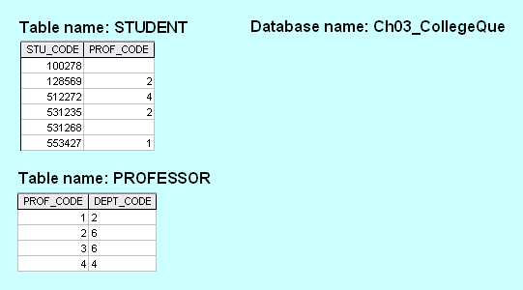

The natural JOIN process begins with the PRODUCT of the two tables. Next, a SELECT (or RESTRICT) is performed on the PRODUCT generated in the first step to yield only the rows for which the PROF_CODE values in the STUDENT table are matched in the PROF table. Finally, a PROJECT is performed to produce the natural JOIN output by listing only a single copy of each attribute. The order in which the query output rows are shown is not relevant.

STU_CODE | PROF_CODE | DEPT_CODE
128569 | 2 | 6
512272 | 4 | 4
531235 | 2 | 6
553427 | 1 | 2

The equiJOIN's results depend on the specified condition. At this stage of the students' understanding, it may be best to focus on equijoins that retrieve all matching values in the common attribute. In such a case, the output will be:
STU_CODE | STUDENT. PROF_CODE | PROFESSOR.PROF_CODE | DEPT_CODE
128569 | 2 | 2 | 6
512272 | 4 | 4 | 4
531235 | 2 | 2 | 6
553427 | 1 | 1 | 2

Notice that in equijoins, the common attribute appears from both tables. It is normal to prefix the attribute name with the table name when an attribute appears more than once in a table. This maintains the requirement that attribute names be unique within a relational table.

In the Outer JOIN, the unmatched pairs would be retained and the values that do not have a match in the other table would be left null. Outer Joins are not the opposite of Inner Joins (like Natural Joins and Equijoins). Rather, they are "Inner Join Plus" – they include all of the matched records found by the Inner Join plus the unmatched records. Outer JOINs are normally performed as either a Left Outer Join or a Right Outer Join so that the operator specifies which table's unmatched rows should be included in the output. Full Outer Joins depict the matched records plus the unmatched records from both tables. In addition, like Equijoins, Outer Joins do not drop a copy of the common attribute. Therefore, a Full Outer Join will yield these results:

STU_CODE | STUDENT. PROF_CODE | PROFESSOR.PROF_CODE | DEPT_CODE
128569 | 2 | 2 | 6
512272 | 4 | 4 | 4
531235 | 2 | 2 | 6
553427 | 1 | 1 | 2
100278
531268
 |  | 3 | 6

A Left Outer Join of STUDENT to PROFESSOR would include the matched rows plus the unmatched STUDENT rows:

STU_CODE | STUDENT. PROF_CODE | PROFESSOR.PROF_CODE | DEPT_CODE
128569 | 2 | 2 | 6
512272 | 4 | 4 | 4
531235 | 2 | 2 | 6
553427 | 1 | 1 | 2
100278
531268

A Right Outer Join of STUDENT to PROFESSOR would include the matched rows plus the unmatched PROFESSOR row.
STU_CODE | STUDENT. PROF_CODE | PROFESSOR.PROF_CODE | DEPT_CODE
128569 | 2 | 2 | 6
512272 | 4 | 4 | 4
531235 | 2 | 2 | 6
553427 | 1 | 1 | 2
 |  | 3 | 6

